Johnny Foley’s Irish House
243 O'Farrell St, San Francisco, CA 94102 (415) 954-0777
4-minute walk from the Hilton johnnyfoleys.com
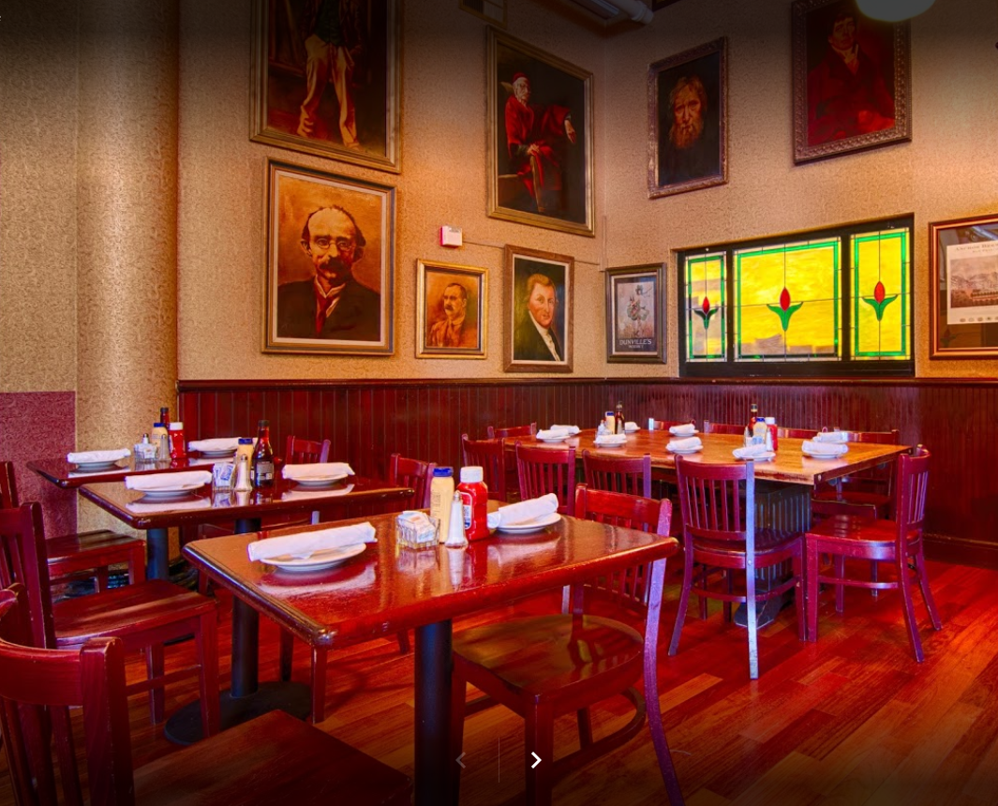

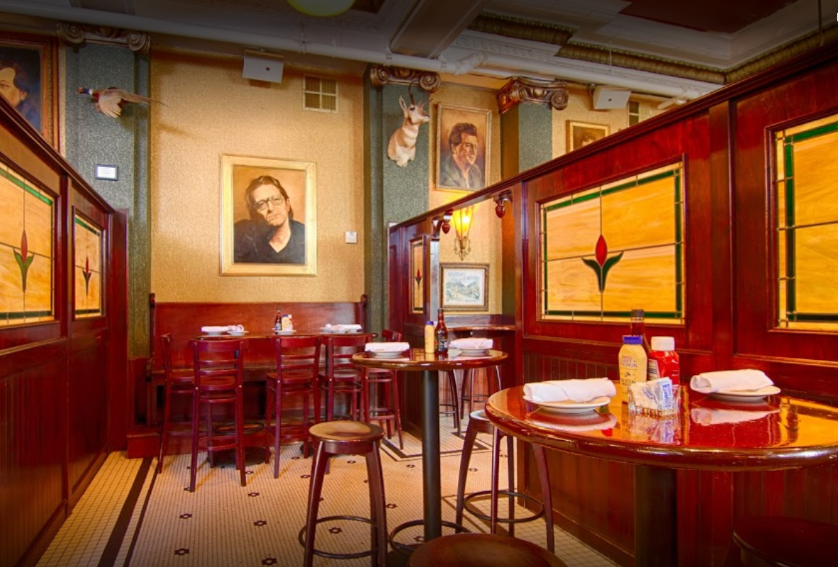

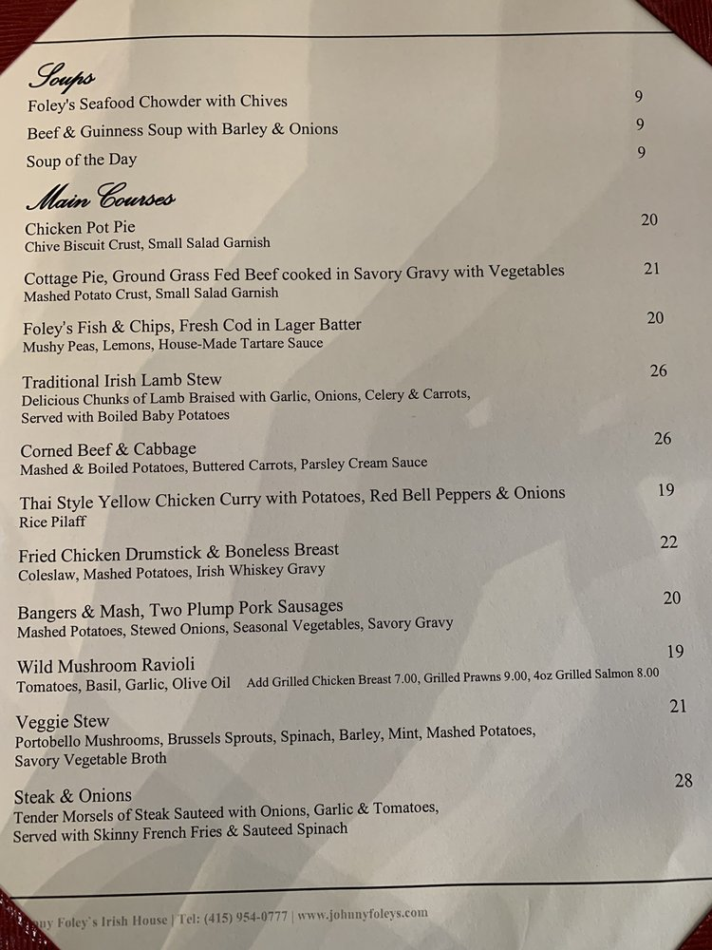
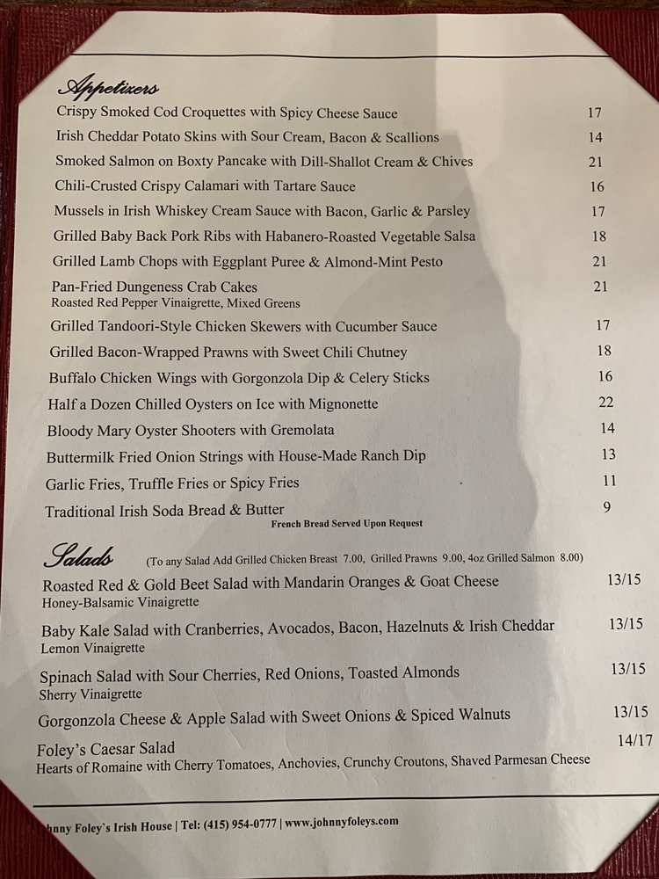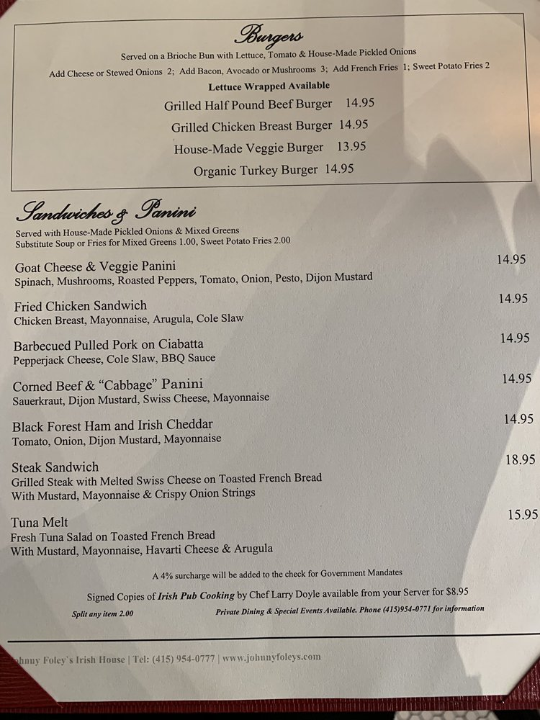
Can do separate checks. Need to tell the server beforehand

