Million Thai Restaurant
385 Taylor St, San Francisco, CA 94102 (415)525-4090
1-minute walk from Hilton millionthai-sf.com
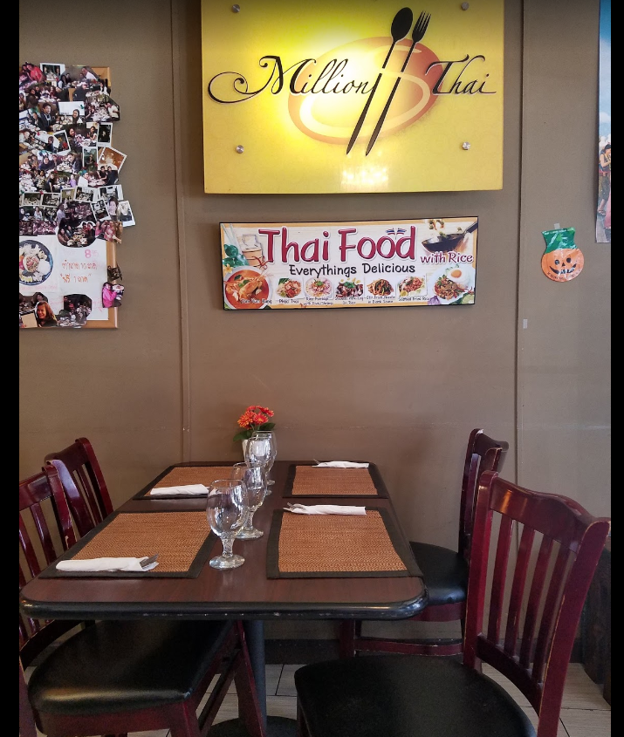

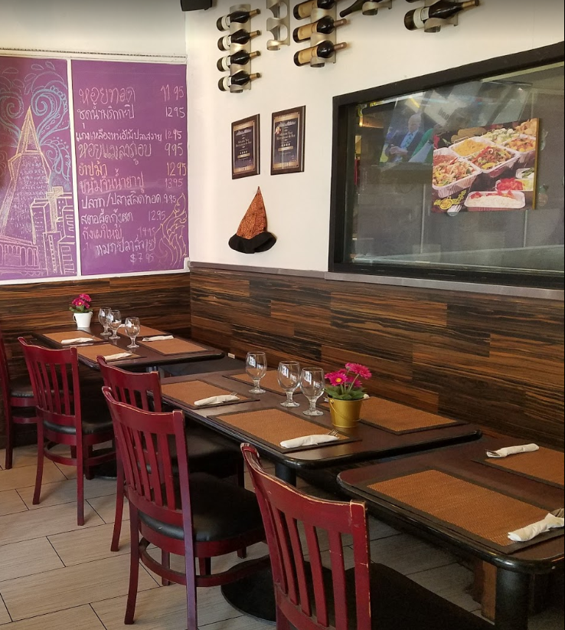
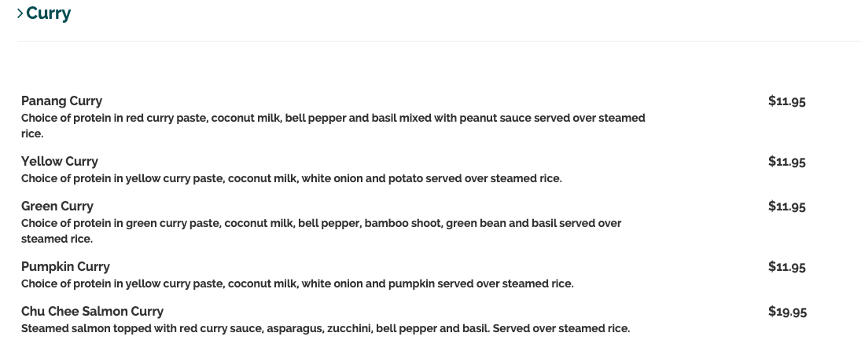
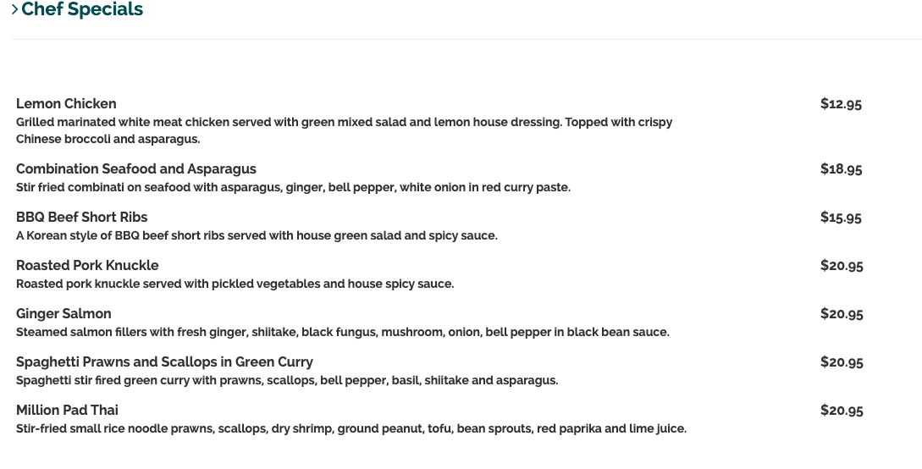
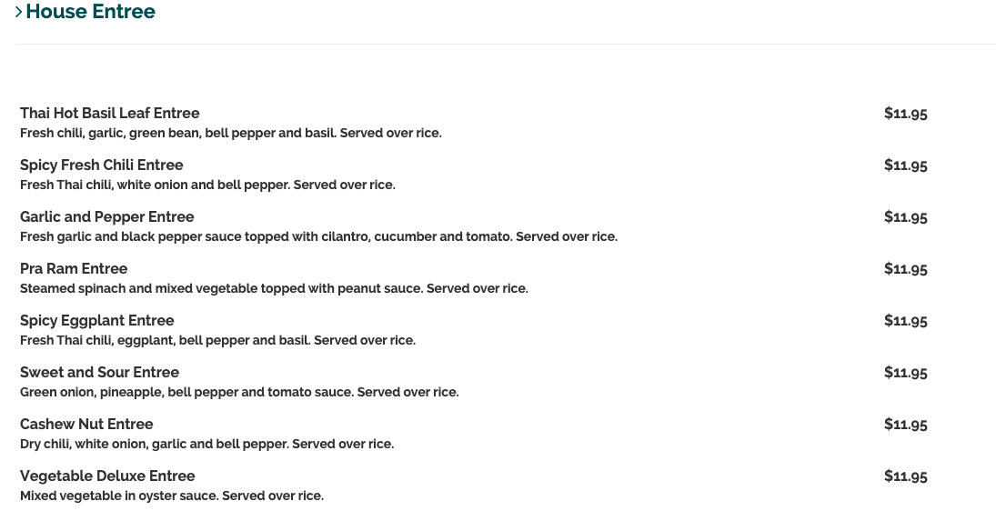
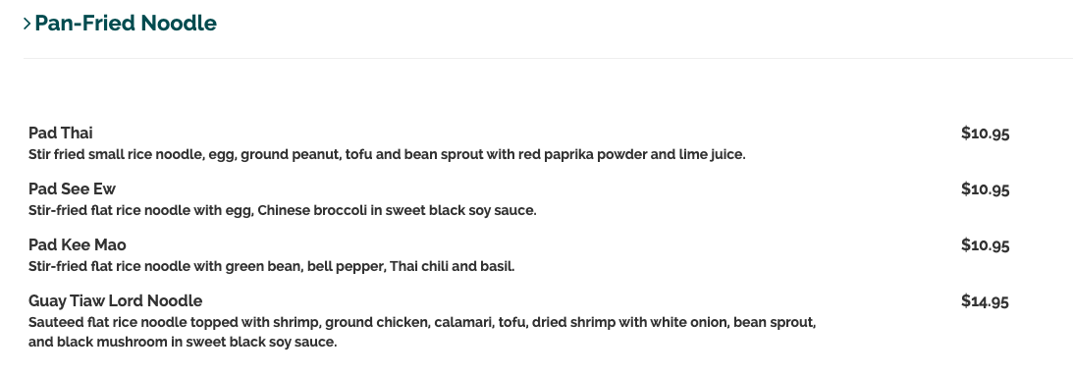

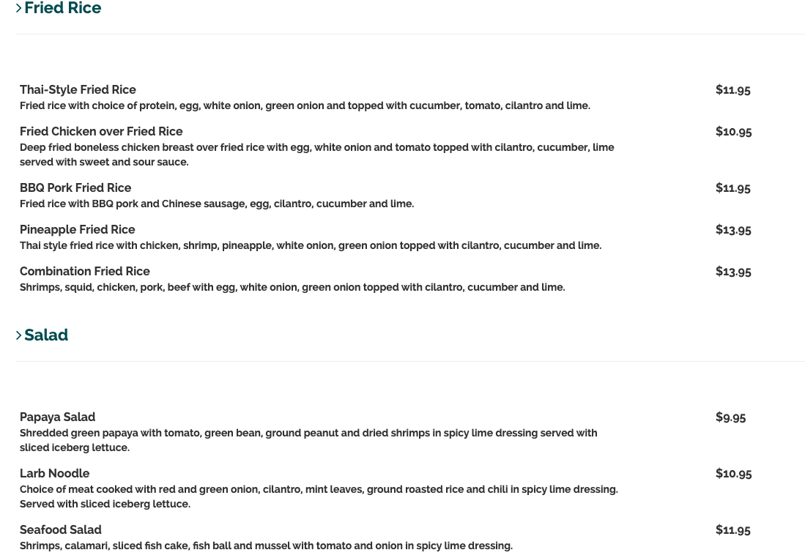

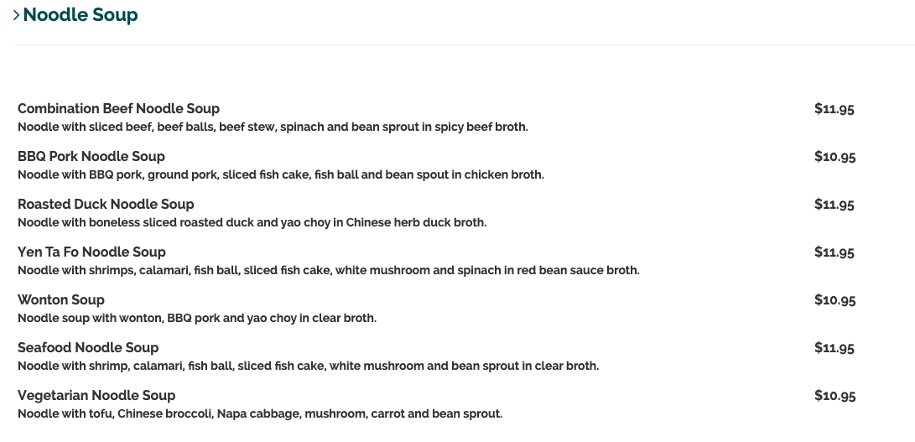
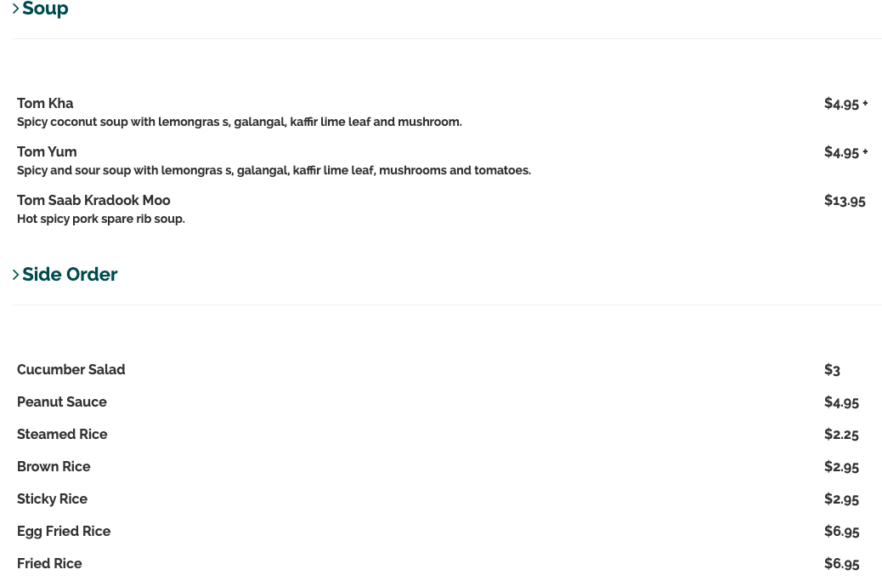
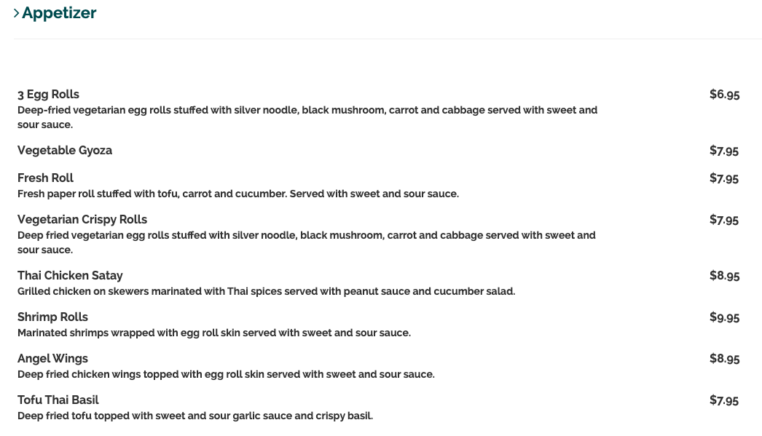

Beverage

Thai Hot Tea -$1.5
Soft Drink- $2.25
Thai Iced Tea- $2.95
Thai Iced Coffee- $2.95
Sparkling Water- $2.95
Bottled Water - $1.5

Can split checks into 3-4 groups of people

